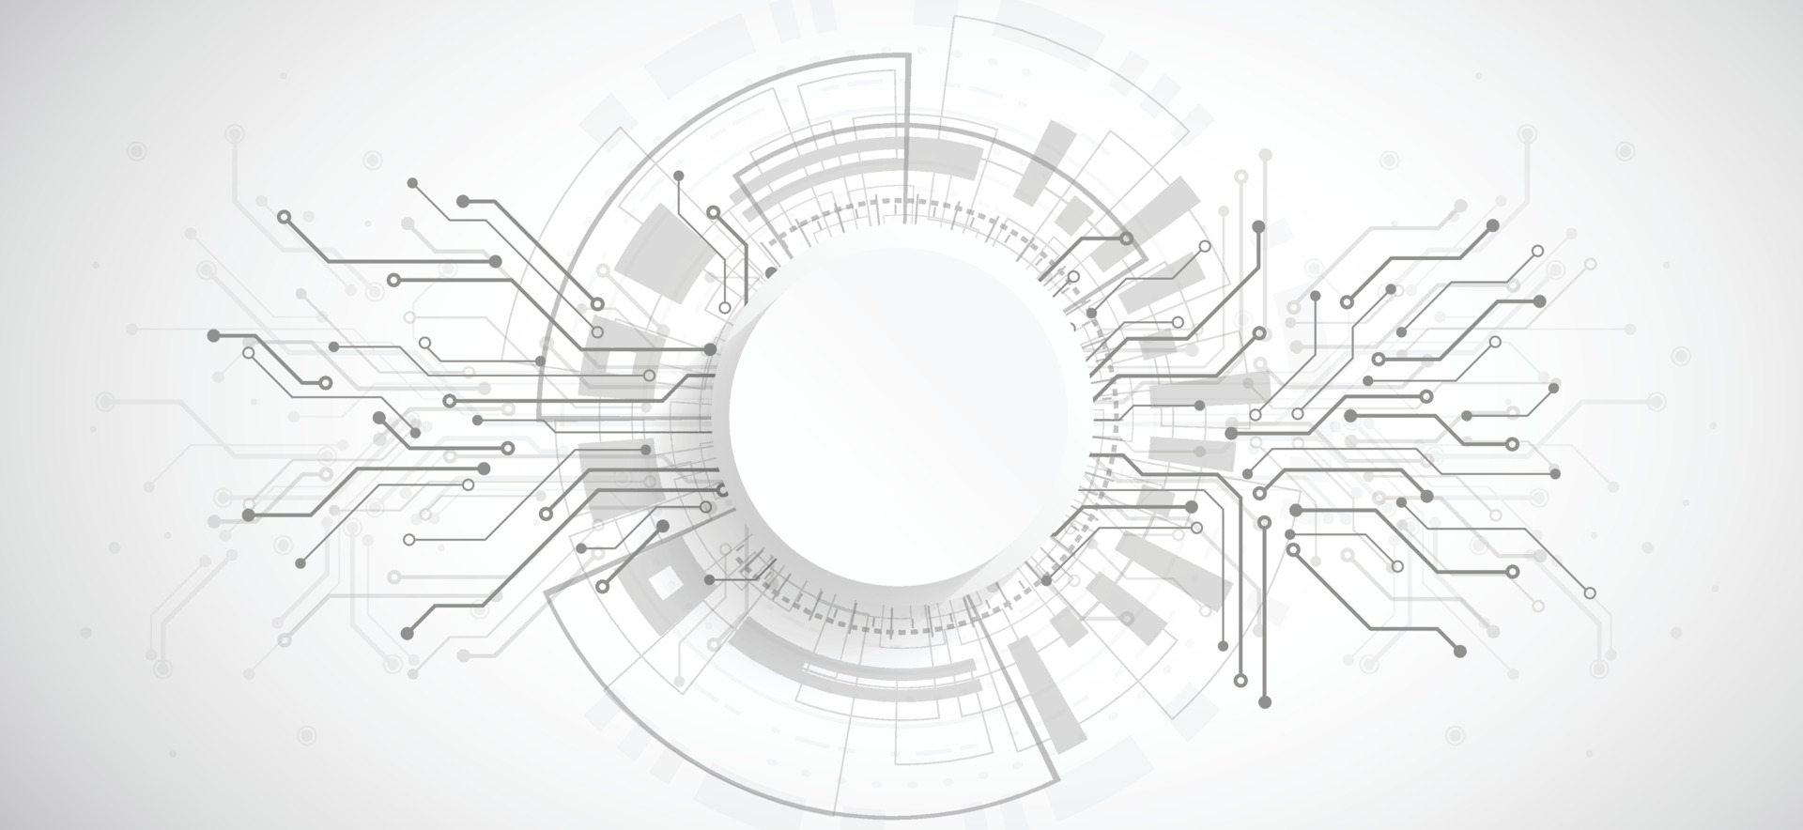



**Make your Drive Digital**

**Components Rport**

**Member 1: Member 2:**

**Muhammad Fahad Ahmed Amin**

**(FA19-BSSE-0014) (FA19-BSSE-0063)**

**(Leader)**

**Supervisor:**

**Dr Shaukat Wasi**

**Tuesday, October 18, 2022**